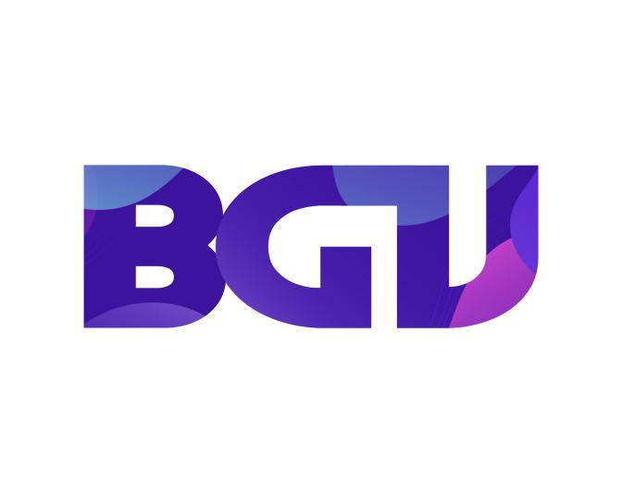

**Music Lesson**

### **1/Introduce**

Music is the inspiration of most people all over the world and it has the ability to alleviate all stresses and stresses in life. And from a young age, we already know the potential of children in music and are able to develop their talents through our course. BGV gifted training school will bring children quality and useful knowledge. At the same time, our credibility will ensure credibility with parents.

**2/Class time :**

* Basic class: 3 months (3 times/week)
* Advanced class: 2 months (3 times/week)

**3/The content of the course :**

**Basic Class :**

* Learn vocal basic.
* How to take breath, hold it, regulate and process it.
* Practice different long and short intervals in vocal vibrations.
* Ensure the right rhythm, pitch, take the right place slightly.

**Advanced Class :**

* Good handling of nuances, song structure subtly with emotion.
* Performs confidently, has good breath control, during the singing process, there is no difference, show …
* Build your own songs combined with building your own personal style.

**4/The tuition fees of the courses are as follows :**

- For Basic Classes: The course lasts 3 months with tuition of 500$ and we are committed to the best teaching quality for the children.

- For Advanced Classes: The course lasts 4-month course with a cost of 600$, we are committed to the best teaching quality for our children.